

GENERAL PROCEDURE

for
ULTRASONIC testing

DOCUMENT NUMBER: | IQMS-UT-P-001
REVISION: | 00
DOCUMENT DATE: | 22 JUNE 2017

18 Greybeard Road, Sandrift-North, Milnerton, 7441
Tel / Fax: +27(0) 21 555 2973 Mobile: +27(0) 79 957 2869
Email: cpt@iqms.co.za Website: www.iqms.co.za
Contents
1. PURPOSE 4
2. SCOPE 4
3. REFERENCING CODE SPECIFICATIONS 4
4. DEFINITIONS AND ABBREVIATIONS 4
5. NORMATIVE REFERENCES 5
6. REQUIREMENTS 5
6.1 Safety 5
6.2 Precautions and Limitations 5
6.3 Personnel Requirements 5
6.4 Equipment Requirements 5
6.5 Consumable Requirements 5
6.6 Location and Component Identification 6
7. TESTING VOLUME 6
8. PREPARATION OF SCANNING SURFACES 6
9. PARENT METAL TESTING 6
10. RANGE AND SENSITIVITY SETTING 7
11. REFERENCE FOR SENSITIVITY SETTING 7
12. EVALUATION LEVELS 7
13. TRANSFER CORRECTION 7
14. SIGNAL TO NOISE RATIO 7
15. SCANNING SENSITIVITY 8
16. SCAN PATH OVERLAP 8
17. SCANNING SPEED 8
18. MANUAL SCAN PATH 8
19. WELD SCAN FOR LONGITUDINAL IMPERFECTIONS 8
20. WELD SCAN FOR TRANSVERSE IMPERFECTIONS 9
21. LOCATION OF INDICATIONS 9
22. SIZING OF INDICATIONS 9
23. EVALUATION OF INDICATIONS 10
24. DOCUMENTATION 10
APPENDIX 1 – ECHO DYNAMIC PATTERNS 11
Pattern 1: Point Reflector 11
Pattern 2: Extended Smooth Reflector 12
Pattern 3: Extended Rough Reflector (One) 13
Pattern 4: Extended Rough Reflector (Two) 14
Pattern 5: Cluster of Non-Planar 15
APPENDIX 2 – SCAN PATTERN PROPOSALS 16
A. Butt Joints in Plate and Pipe 16
B. T-Joints 17
C. Set-Through Nozzles 18
D. L-Joints 19
E. Set-On Nozzles 20
APPENDIX 3 – ASME VIII, DIVISION 1, APPENDIX 12 21
APPENDIX 4 – ASME B31.1 22
APPENDIX 5 – ASME B31.3 23
APPENDIX 6 – IQMS GROUP UT REPORT FORMAT 24

PLEASE NOTE
This Document replaces all previous discussions, understandings and revisions of this written procedure for Ultrasonic Testing utilized by IQMS Group.

PURPOSE

This Procedure details the method to perform Manual Ultrasonic Testing by Authorized Personnel on behalf of IQMS GROUP.

SCOPE

Applicable to all Carbon Steel, Butt welds in plate and pipe, Nozzles and T-Joints and L-Joints with thickness ranges between 8mm and 50mm when the Procedure Code is:

ASME V Article 4 (2015) | ASME Boiler and Pressure Vessel Code, Section V: Nondestructive Examination  Article 4: Ultrasonic Examination Methods for Welds

REFERENCING CODE SPECIFICATIONS

The applicable version and addendum of the referencing code specifications shall be stipulated by the client, AND a working copy may be requested by the Company from the client prior to conducting work under this procedure.

ASME B31.1 (2014/2016) | Power piping
ASME B31.3 (2014/2016) | Process Piping
ASME VIII (2015) | ASME Boiler and Pressure Vessel Code, Section VIII, Div 1: Rules for Construction of Pressure Vessels

(Usually the latest (current) edition of a Code/Specification is applicable. Specific editions of the Codes/Specifications used, must be specified on the Radiographic Report Sheet as the Customer may have specific requirements.)

DEFINITIONS AND ABBREVIATIONS

NDT | Non-Destructive Testing
UT | Ultrasonic Testing
Technician (Operator) | An authorized Level II or III UT Technician authorized by the Company in accordance with IQMS-WP-001.
The Company | IQMS GROUP
BWE | Back Wall Echo
FSH | Full Screen Height
FSW | Full Screen Width
SDH | Side Drilled Hole
DAC | Distance Amplitude Correction

NORMATIVE REFERENCES

IQMS-WP-001 | Written Practice for the Qualification, Internal Certification and Authorization of NDT Personnel.
IQMS-WP-002 | Written Practice for the Performance of NDT Equipment.

REQUIREMENTS

6.1 Safety
- Any additional couplant manufacturer’s safety precautions must be observed.
- Before any electrical equipment is used, the technician shall satisfy himself that there shall be no danger or hazard from fire as a result of any overheating or sparking.
- Wet Floors: Slipping on a floor wetted with couplant medium may be possible. Exercise caution during the inspection to this regard.

6.2 Precautions and Limitations
- All required information (e.g. weld configuration, drawings, material type, etc.) regarding the component shall be supplied by the client before Ultrasonic inspection can be done.
- Technique parameters shall be recorded on the Ultrasonic Report.

6.3 Personnel Requirements
- Ultrasonic Testing Operators, Evaluators and Reviewers shall be authorized in accordance with the requirements of IQMS-WP-001.
- Only Personnel Authorized as a Level II or Level III Technician by the Company shall be allowed to perform Ultrasonic Inspection.
- Interpretation, Evaluation and Reviewing of Radiographs shall only be done by Authorized Level II or Level III Technicians.

6.4 Equipment Requirements
- All equipment used shall be in a safe working condition and calibrated as required in accordance with the applicable Procedure Code and IQMS-WP-002.
- Daily calibrations shall be done by a Qualified Technician in accordance with IQMS-WP-002.
- The Ultrasonic Flaw Detector to be used shall be an A-scan detector with graticule scale markings capable of operating in the frequency range of 1 to 5 MHz.
- The frequency of the probes shall be within the range 2 MHz to 5 MHz.
- Under most circumstances 4-5 MHz probes shall be used, unless otherwise.
- Frequencies of as low as 2 MHz may be used for testing at long sound paths where the material shows above average attenuation.
- The following probes shall be available for use: 45° Single Crystal Shearwave, 60° Single Crystal Shearwave, 70° Single Crystal Shearwave, 0° Single Crystal Compression wave and 0° Twin Crystal Compression wave.
- Shearwave probes shall have crystal sizes of 8 x 9mm and Compression probes shall be minimum 10 mm Ø.
- When curved surfaces are tested, the probe shoe shall be contoured to assure that the gap between the test surface and the bottom of the probe shoe shall not be greater than 0.5 mm.
- Calibration and Reference blocks used shall be made from the same material group, heat treatment and surface finish as the component to be inspected.
- The temperature of the calibration and reference blocks shall be within 14°C of the component to be inspected.
- The following standard calibration and reference blocks shall be available: V1 (A2), V2 (A4), A5, A7 and DAC.

6.5 Consumable Requirements
- The couplant, including additives, shall not be detrimental to the material being examined. A gel or paste with a smooth consistent texture or water shall be used, unless otherwise required by the Client. The chloride contents of water must be 250ppm for carbon steel and 50ppm for stainless steel.

6.6 Location and Component Identification
- Each item shall be identified on a work request together with an inspection package. At each weld location a physical identification should be present, i.e. Plant Location Code (PLC).
- In cases where the inspection package and physical identification nomenclature cannot be reconciled, NO inspection shall be performed until resolution is provided by the Client.
- Where temporary identification is allowed, the operator shall ensure that the type of marking will remain present for any period of re-work, should repairs be necessary. The operator shall establish a zero reference datum related to some prominent feature of the item (e.g. Top Dead Centre), which shall be detailed in the inspection report.

TESTING VOLUME

- The testing volume (see Figure 1) is defined as the zone which includes weld and parent material for at least 10 mm on each side of the weld, or the width of the heat-affected zone, whichever is greater. In all cases, scanning shall cover the whole testing volume.

PREPARATION OF SCANNING SURFACES

- Scanning surfaces shall be wide enough to permit the testing volume (see Figure 1) to be fully covered. Alternatively, the width of the scanning surfaces may be smaller if equivalent coverage of the testing volume can be achieved by scanning from both the upper and the lower surface of the joint.
- Scanning surfaces shall be even and free from foreign matter likely to interfere with probe coupling (e.g. rust, loose scale, weld spatter, notches, grooves). Waviness of the test surface shall not result in a gap between the probe and test surfaces greater than 0,5 mm. These requirements shall be ensured by dressing if necessary. Local variations in surface contour, e.g. along the edge of the weld, which result in a gap beneath the probe of up to 1 mm, can only be permitted if at least one additional probe angle is employed from the affected side at the weld. This additional scanning is necessary to compensate for the reduced weld coverage that will occur with a gap of this dimension.
- Scanning surfaces and surfaces from which the sound beam is reflected shall allow undisturbed coupling and reflection.

PARENT METAL TESTING

- The parent metal, the scanning zone area (see Figure 1), shall be examined with a 0° (Twin Crystal for materials less than 10mm thick) probe prior to or after welding.
- Where imperfections are found, their influence on the proposed angle beam testing shall be assessed and, if necessary, the techniques adjusted correspondingly. When satisfactory coverage by ultrasonic testing is seriously affected, other inspection techniques (e.g. radiography) shall be considered.

Figure 1 (Dimensions in millimetres)
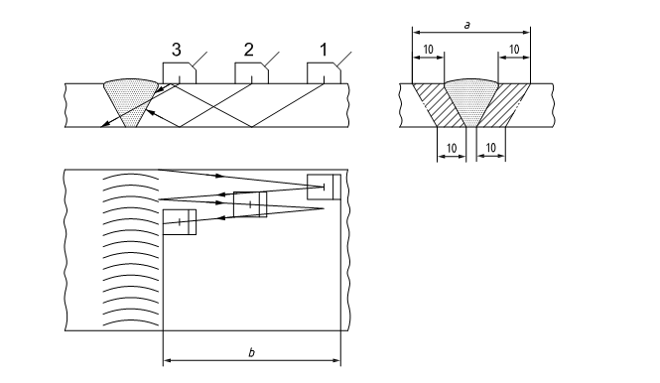

Key:
- Position 1
- Position 2
- Position 3
- Width of Testing volume
- Scanning zone width (Stand-off)

RANGE AND SENSITIVITY SETTING

- Setting of range and sensitivity shall be carried out prior to each inspection, taking the influence of temperature into account. The temperature difference during range and sensitivity setting and during the test shall be within ±14°C.
- Checks to confirm these settings shall be performed at least every 4 hours and on completion of the testing. Checks shall also be carried out whenever a system parameter is changed or changes in the equivalent settings are suspected.
- If deviations are found during these checks, the corrections given in Table 1 shall be carried out.

Table 1 – Sensitivity and Range Corrections
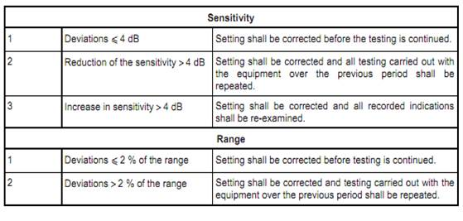

REFERENCE FOR SENSITIVITY SETTING

- The scanning sensitivity, when testing plates, with 0° probes, for laminations, shall be 2nd BWE @ FSH as established on the part to be inspected.
- For welds the reference is a distance-amplitude curve (DAC) for side-drilled holes of diameter 3 mm.

EVALUATION LEVELS

- All indications greater than 20% of the reference level shall be investigated to the extent that they can be evaluated in terms of the acceptance criteria of the referencing Code Section.

TRANSFER CORRECTION

- When separate blocks are used for establishing reference levels, a measurement shall be made of the transfer differences, between test object and block.
- If the differences are less than 2 dB, correction is not required.
- If the differences are greater than 2 dB but smaller than 12 dB, they shall be compensated for.
- If transfer losses exceed 12 dB, the block will not be suitable for establishing reference levels.

SIGNAL TO NOISE RATIO

- During testing of the weld, the noise level, excluding spurious surface indications, shall remain at least 12 dB below the evaluation level.

SCANNING SENSITIVITY

- The Parent Metal Scanning sensitivity shall be set on an area free from imperfections on the parent material with the second back wall echo at full screen height.
- The Weld Scanning Sensitivity shall be as per Table 2.

Table 2 – Weld Scanning Sensitivity.
NORMAL BEAM SCANS | REFERENCE + 8 dB's
CRITICAL ROOT SCANS | REFERENCE + 14 dB's
SCANS FOR LONGITUDINAL IMPERFECTIONS | REFERENCE + 14 dB's
SCANS FOR TRANSVERSE IMPERFECTIONS | REFERENCE + 20 dB's

SCAN PATH OVERLAP

- Each pass of the search unit shall overlap a minimum of 10% of the transducer (piezoelectric element) dimension parallel to the direction of scan indexing.

SCANNING SPEED

- The choice of scanning speed shall take into consideration the pulse repetition frequency and the ability of the operator to recognize or of the instrument to record signals. This shall be less than 100 mm per second.

MANUAL SCAN PATH

- During angle probe scanning (as illustrated in Figure 1), a slight swivelling movement up to an angle of approximately 10° on either side of the nominal beam direction shall be applied to the probe.

WELD SCAN FOR LONGITUDINAL IMPERFECTIONS

- Regardless of the weld cap condition, the weld shall be scanned with more than one angle probe for longitudinal imperfections from both surfaces, where the component configuration allows it. If inaccessibility prevent scanning from both surfaces, it shall be noted as a limitation on the report. The probe angles to be used and scan patterns to be followed shall be as specified in Appendix 2.

WELD SCAN FOR TRANSVERSE IMPERFECTIONS

- The transverse examination shall be performed on the weld cap (Figure 2, position C and D). Where the weld cap is a limitation, the transverse scan shall be performed with the 45º probe positioned parallel and adjacent to the weld cap (Figure 2, position X and Y).
- Using a 45º probe calibrated to full skip range examine the weld body for transverse imperfections in two opposite directions from both sides of the weld.
Figure 2
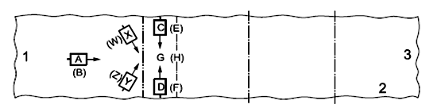

LOCATION OF INDICATIONS

- Both side-view and plan-view sketches shall be included in the report, containing all relevant indications indicating their type, size, orientation, distance from common datum point and reference, and accept or reject.

SIZING OF INDICATIONS

- The technique used for sizing indications shall depend on the echo dynamic pattern of the indication and shall be:

Echo Dynamic Pattern | Sizing Method
Pattern 2 | 6 dB Drop Technique
Pattern 3 and 4 | Maximum Amplitude Technique or 20 dB Drop Technique
Pattern 1 and 5 | Maximum Amplitude

- Additional Specialized UT techniques with better sizing capabilities may be applied if available. These Technique parameters shall be specified on the relevant Procedures and Technique sheets. These specified Techniques may include but are not limited to; Phased Array, ToFD etc.

EVALUATION OF INDICATIONS

- The evaluation of imperfections shall be in accordance with the applicable Reference Code Section (Appendix 3, 4 and 5) unless otherwise required by the Client.
- The Echo Dynamic Pattern method (Appendix 1) shall be used to identify the type of reflector and to separate potentially serious imperfections from less serious imperfections, which might be even at a lower echo height. To determine the echo dynamic pattern, probe movement shall be in two mutually perpendicular directions.
- Classification of indications depends on the patterns observed:
- Pattern 1: point reflector
- Pattern 2: extended smooth reflector
- Pattern 3 and pattern 4: extended rough reflector
- Pattern 5: cluster of non-planar.
This criterion shall be fulfilled for at least two directions of examination.

DOCUMENTATION

- Recording of indications - Recordable indications shall be specified by the referencing code section.
- Rejectable indications - Rejectable indications shall be recorded. As a minimum, the type of indications (linear or rounded), location and extent (length or diameter or aligned) shall be recorded.
- The test report shall be compiled with detailed sketches showing all relevant indications as well as their: type, size, orientation, distance from a common fixed datum reference and indicate their acceptance or rejection. Reporting shall be done on the standard IQMS GROUP Report form (Appendix 6), unless otherwise required by the client.

APPENDIX 1 – ECHO DYNAMIC PATTERNS

Pattern 1: Point Reflector

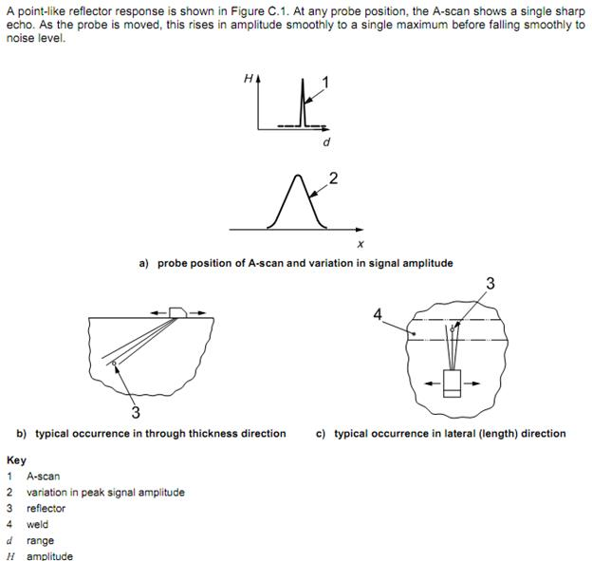

Pattern 2: Extended Smooth Reflector

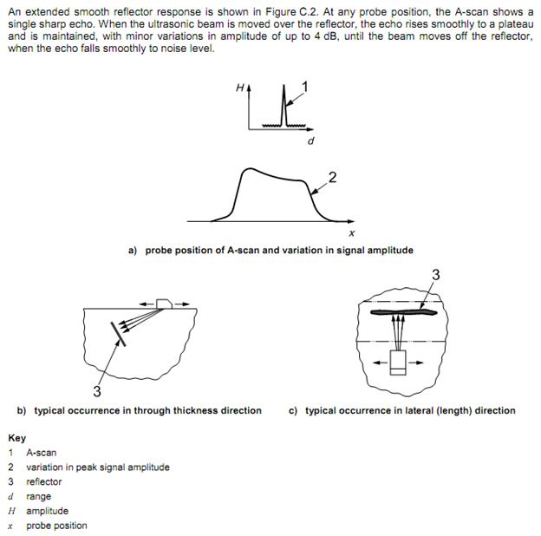

Pattern 3: Extended Rough Reflector (One)

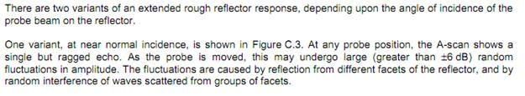
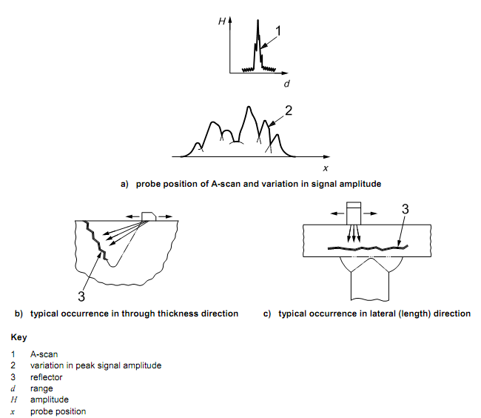

Pattern 4: Extended Rough Reflector (Two)

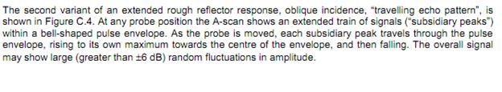
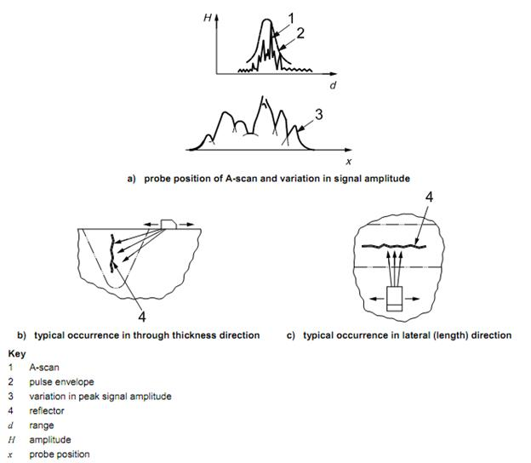

Pattern 5: Cluster of Non-Planar


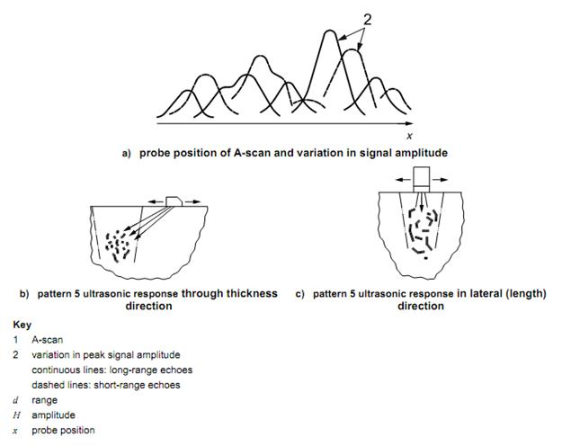

APPENDIX 2 – SCAN PATTERN PROPOSALS

Butt Joints in Plate and Pipe

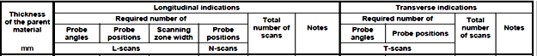
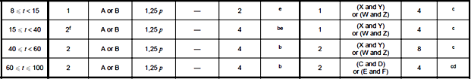
Notes:
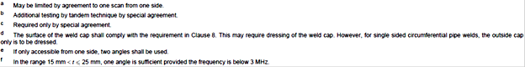

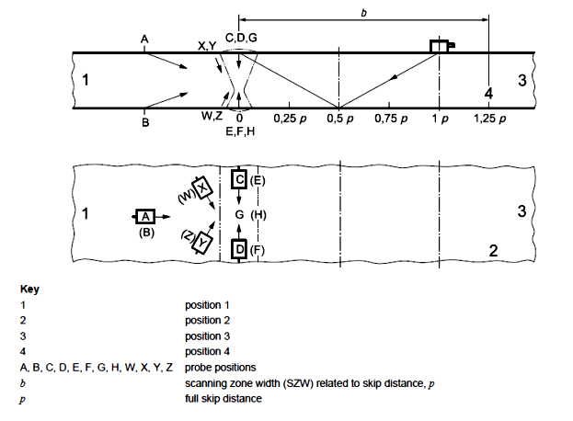

T-Joints

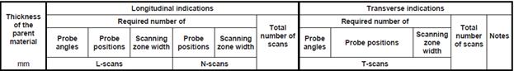
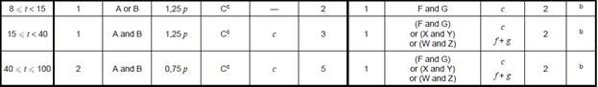

Notes:
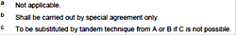

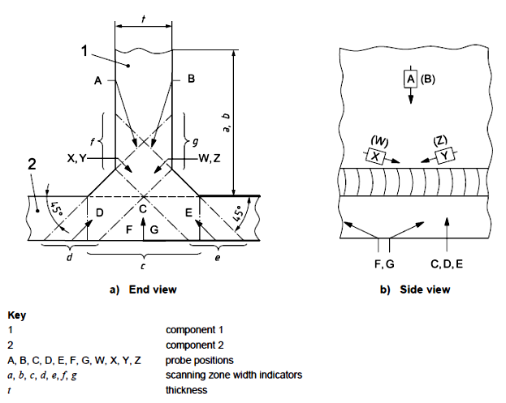

Set-Through Nozzles

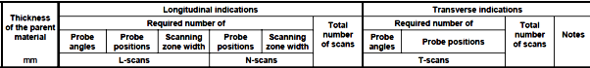
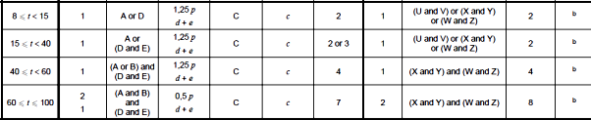

Notes:

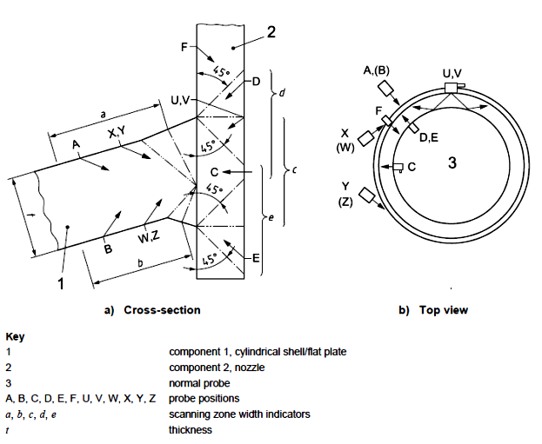

L-Joints

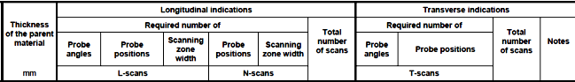

Notes:

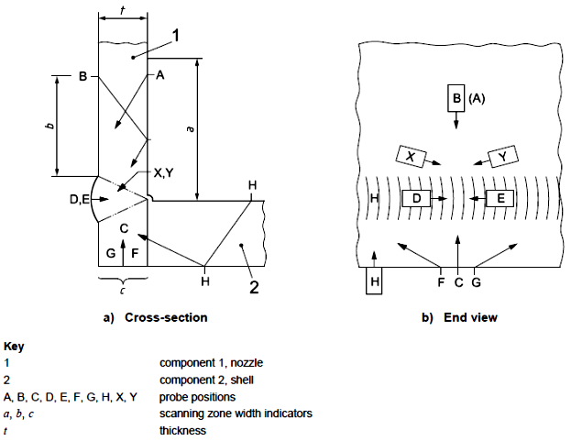

Set-On Nozzles

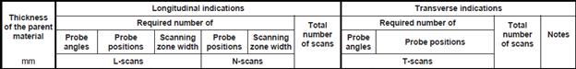
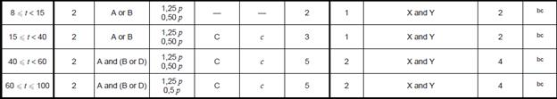

Notes:

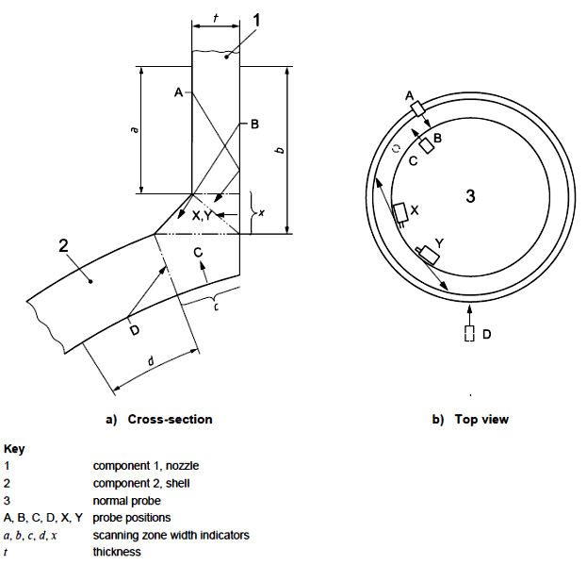

APPENDIX 3 – ASME VIII, DIVISION 1, APPENDIX 12

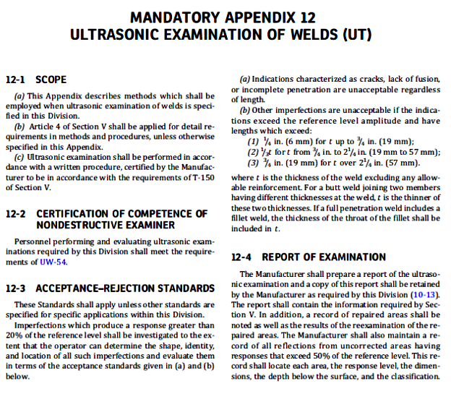

APPENDIX 4 – ASME B31.1

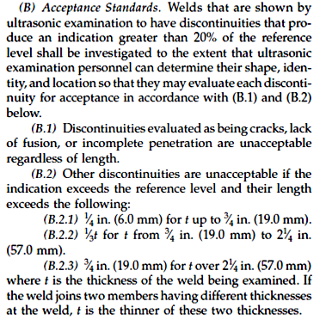

APPENDIX 5 – ASME B31.3

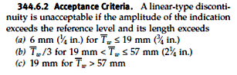

APPENDIX 6 – IQMS GROUP UT REPORT FORMAT

